**Lemon Grass Tea**

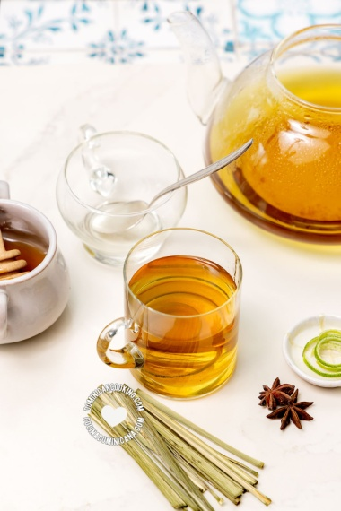

**INGREDIENTS**

A small bunch of lemongrass leaves, rinsed

4 star anise

4 pieces of lime rind, or 2 tablespoon of lemon juice

4 tablespoons Honey , or sugar (or to taste)

**METHOD**

Pour 6 cups of water into a medium saucepan or small pot.

Add the lemongrass and star anise and boil over medium-low heat for 15 minutes

Serving

Stirring lemongrass tea.

Strain the liquid and discard the solids. Pour it into 4 cups, and add a piece of lime rind to each cup of lemongrass tea.

Add honey or sugar to taste and serve hot.